Managing SELinux (Basics)

Tasks

1. Check the current SELinux status on your Linux system using the getenforce and sestatus commands, and write down what each output means.

ANS:

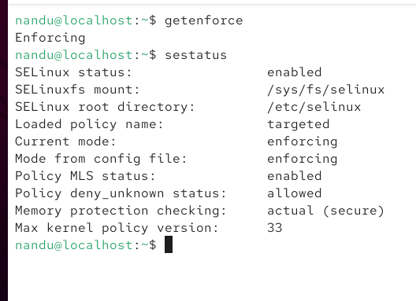

2. Switch SELinux to permissive mode temporarily using the setenforce command, then try creating a new file in /var/www/html and note any differences in error messages or permissions compared to enforcing mode. Use setenforce 0 for permissive and setenforce 1 to return to enforcing.

ANS:

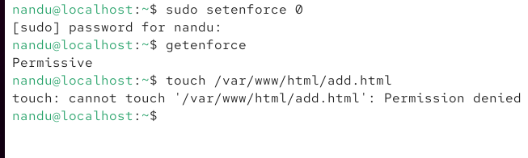

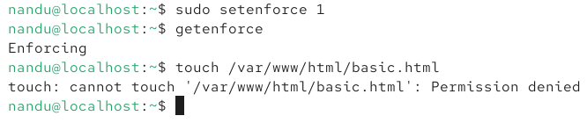
After changing SELinux to Permissive mode using setenforce 0, I still got a “Permission denied” error when trying to create /var/www/html/add.html. When I changed it back to Enforcing mode using setenforce 1, I got the same error while creating /var/www/html/basic.html. This shows that the issue was caused by the normal Linux file permissions of the /var/www/html directory, not just SELinux.

3. List all files in /var/www/html and use the ls -Z command to display their SELinux security contexts. Change the context of one file to httpd_sys_content_t using chcon and verify the change. Use chcon --type=httpd_sys_content_t filename.

ANS;

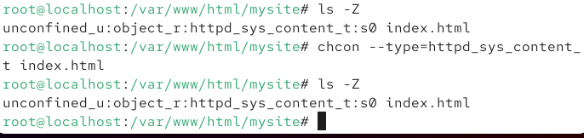

4. A user is unable to upload images to a folder for their food review blog (like Zomato) hosted in /srv/foodie/images. Use the audit2why and audit2allow tools to analyze SELinux denial logs and suggest a solution to allow uploads. Check /var/log/audit/audit.log for recent denials.

ANS:

